DEAR GUESTS,

A warm welcome at our accommodation!
We wish that your stay is remembered in good spirits and that we make as pleasurable for you as possible.

We are an environmentally friendly family, and we follow the following rules:
• WE DO OUR BEST TO ACT ENVIRONMENTALLY CONSCIOUSLY.
• WE INFORM OUR FRIENDS, FAMILY, AND GUESTS TO DO THE SAME.
• WE DILIGENTLY TAKE INTO CONSIDERATIONS TIPS AND SOLUTIONS FOR RESPONSIBLE HANDLING OF NATURAL RESOURCES AND EFFICIENT ENERGY USE.

We are aware that such handling is first and foremost valuable for the environment. We don’t need to do much to act more responsibly to the environment. We don't have to say no to leisure and other things we enjoy to do. For the most part, those are simple and barely noticeable acts. But with a few simple precautions, we can collaboratively make this world a better place to live. And also leave it in equally good shape to our descendants.

As we are in the process of acquiring an environmental sign, we ask you to bear with us as we present you with “environmental sparks.” Namely, awareness of our guests is our duty in obtaining the environmental sign. We will be glad to see you put our propositions into action. As well we are happy to hear all of your further suggestions and comments. We will try to either implement them or forward them to competent institutions.

WITH KIND REGARDS

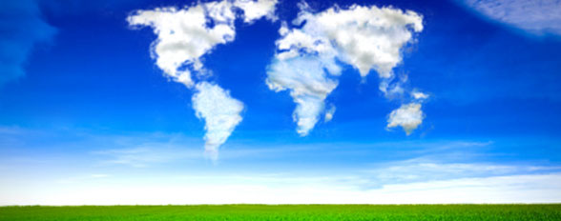
EXAMPLES OF SPARKS:

- Small staps for smaller watter usage:
A person needs about 80 liters of fresh water per day for the sustainable living. In Slovene households, we use somewhere from 130 to 200 liters per person. Only flushing the toilet comes with 2 to 8 liters of fresh drinking water, while for cooking we use about 6 liters of water per day.

If we add to this also the industrial use of water, the numbers increase to 300 to 500 liters per person per day.

DEAR GUESTS, WE ARE HAPPY TO HOST YOU IN AN AREA OF OUR PLANET, WHERE THE WATER IS DRINKABLE!! THE WATER IS AS CLEAN AS IT GETS! SO, FILL FREE TO FILL A GLASS OR A BOTTLE OF FRESH WATER FROM THE TAP.

- TURN OFF THE TAB DURING BRUSHING YOUR TEETH AND SAVE UP TO 18 LITERS OF WATER PER MINUTE.
- ADAPT THE CURRENT ACCORDING TO YOUR NEEDS.

- While cooking:
  - When possible, choose the right pan for the size of the cooking plate.
  - When it comes to boiling, simmer the power.
  - Use lids to minimize the time of cooking.

- OUR ACCOMMODATION IS WELL-ISOLATED, AND IT HAS ENERGY-EFFICIENT WINDOWS. WE ALWAYS CLOSE DOORS AND WINDOWS BEHIND US. AIR THE ROOMS IN THE MORNING AND THEN CLOSE THE SHUTTERS, PREVENTING HEAT TO ENTER. BY DOING SO, THE ROOMS KEEP COOL AND WE DON’T NEED EXTRA COOLING WITH AIR CONDITIONING. WITH IT, WE LESSEN THE CARBON FOOTPRINT.

- WE HAVE INSTALLED LED LIGHTING.
TURN OFF THE LIGHTS WHEN YOU DON’T NEED THEM. WITH IT, WE PRESERVE THE ENVIRONMENT.

